Thank you for your interest in supporting and joining the Friends Group. Individuals can support the park through engaging in a variety of volunteer opportunities, annual membership dues, and donations. To join the Friends Group, please submit the completed form below and send back to the Friends group either by USPS mail or electronically by e-mail. Please use individual forms for multiple persons joining from a family. See instructions and payment options below.

Name (first, last) __________________________________________________________

Address _________________________________________________________________

E-mail address ____________________________________________________________

Phone number ____________________________________________________________

Today’s Date ______________________

Annual Membership Dues $10

Additional Donation (if desired) _____________

Total Payment _____________ Check box if PayPal payment made

There are two ways to submit this form/make payment:

- Mail completed form along with a check made out to:

Friends of Machicomoco State Park
3601 Timberneck Farm Road
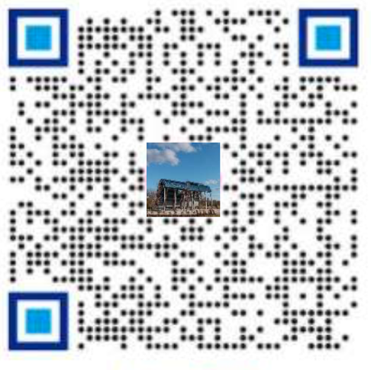
Hayes, VA 23072

- Electronically in 2 steps

  - E-mail completed form to:

friendsofmachicomoco@gmail.com

  - Submit PayPal payment using QR code.
Please indicate “FOM membership” and
List name on payment submitted

